### Tableau Lecture 5: Level of Detail (LoD) calculation

#### **Agenda**

* Using parameters to make visualizations more interactive
* Data aggregation and granularity
* Level of detail calculation

Dataset: [sample superstore](https://docs.google.com/spreadsheets/d/1qduCkeB6NRyvK3qUhny3XTdVX2sq2frT/edit?usp=share_link&ouid=100659516601446935794&rtpof=true&sd=true)

**Using parameters to make visualizations more interactive**

* Parameters are useful when you want to add interactivity and flexibility to a report, or to experiment with what-if scenarios.
* Suppose you are unsure which fields to include in your view or which layout would work best for your viewers.
* You can incorporate parameters into your view to let viewers choose how they want to look at the data.

#### **Business problem 1:**

Allow users to select the field against which they want to compare the sales value.

1. Create parameters where we display the fields that they can have on the y axis
   * Open the dropdown menu at the top of the left pane, click on Create Parameter…
   * Enter parameter name as ‘choose parameter’
   * Select data type as string, Allowable values as list
   * Enter customer, product and state in the list of values section. Click OK.

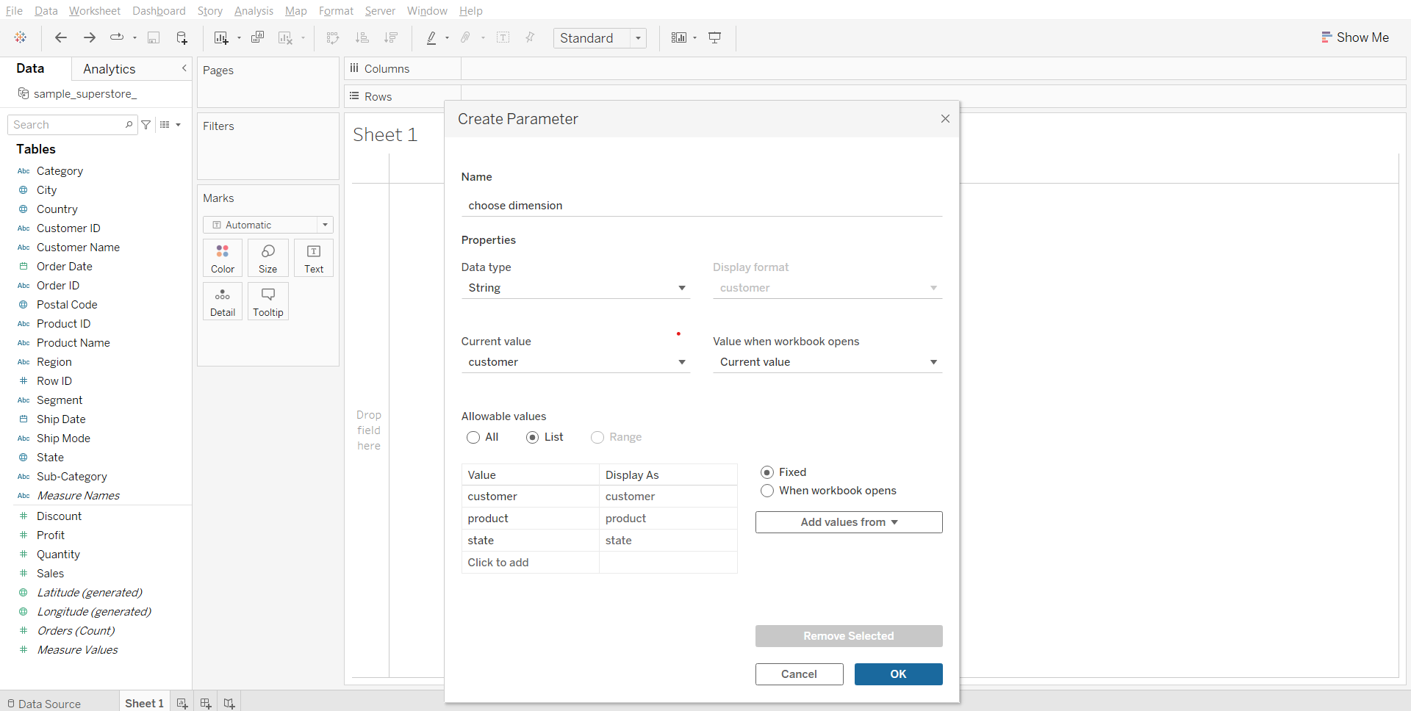

1. Creating a calculated field that will help us select the correct dimension based on the parameter value selected  
    Formula:

CASE [choose dimension]

WHEN 'customer'

THEN [Customer Name]

WHEN 'product'

THEN [Product Name]

WHEN 'state'

THEN [State]

END

Note: The strings in the above formula have to match the string that we had entered when creating the parameter otherwise it won’t work

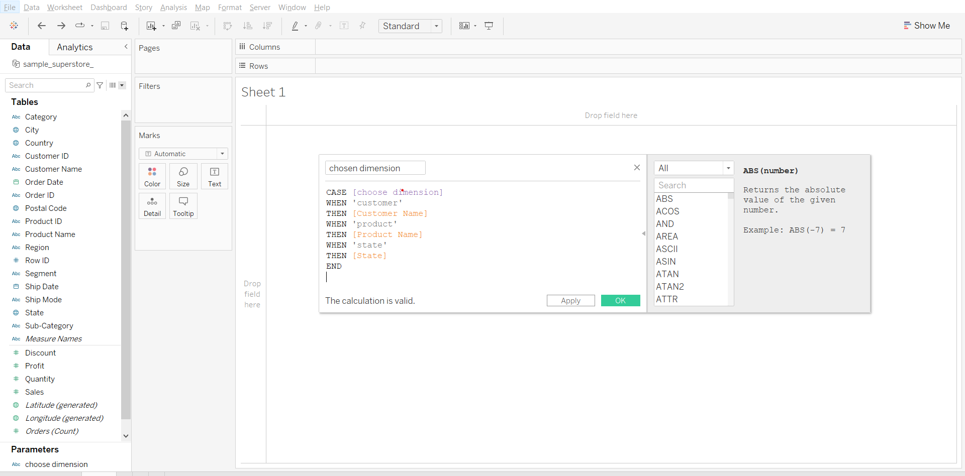

1. Solving the business problem:
   * Drag ‘chosen dimension’ to Rows
   * Drag Sales to Columns
   * Right click choose dimension parameter at the bottom of left pane and click show parameter.
   * Change sheet name to “Sales by <Parameters.choose dimension>” by using insert parameter option.
   * Dimension can now be chosen from the right pane.

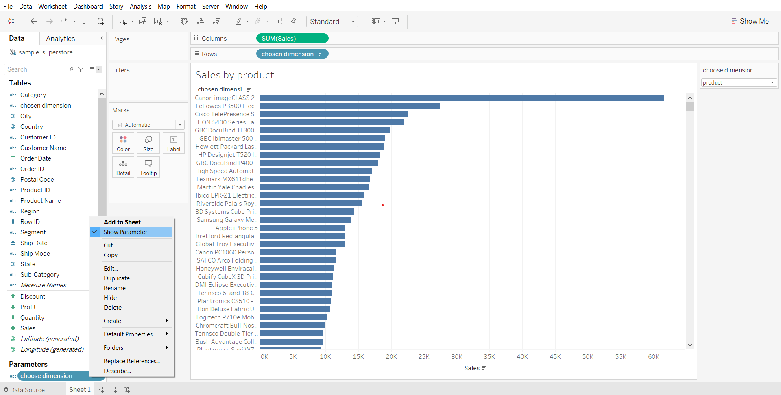

**What is Data Granularity?**

* Data granularity is a measure of the level of detail in a data structure.
* Granularity in simple terms is how detailed the data is.
  + The more detailed, the higher the granularity. (Hence the more rows of data you will have)
  + The less detailed, the lower the granularity. (Vice versa, the less number of rows of data you will have)

Example:

* In time-series data, for example, the granularity of measurement might be based on intervals of years, months, weeks, days, or hours.
* The name field could represent the full name or have separate entries for first name, middle name, and last name.

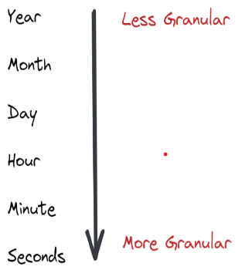

YouTube video for better understanding: [link](https://youtu.be/BZesMeOZCEc)

### **Data Granularity vs Aggregation**

* Granularity and aggregation work opposite of each other.
* In Tableau, when you bring dimensions and measure to the view, the measures are aggregated by whatever dimensions are on the view.
* As you remove and add more dimensions you are decreasing and increasing the granularity. The more dimensions/details on the view, the more granular it is.

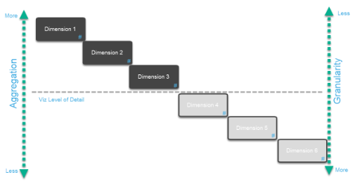

In this example, we have 3 dimensions out on the view so your viz level of detail is that line shown in the photo above. Every measure on your viz will be aggregated at that level which means it will be aggregated by the combination of those 3 dimensions.

### **Why is Data Granularity Important?**

The level of data granularity determines what analysis can be performed on the data, and whether results from that analysis lead to appropriate conclusions.

The more granularity, the more information is available for analysis, but at the cost of increased storage, memory, and required computing resources.

Some analysis may require information to be analyzed at a higher level, which would require aggregating the underlying detail into the higher level of granularity; this is where Level of details works magic.

### **Fixed Level of Detail**

It computes a value using the specified dimension without reference to the dimension in the view.

The FIXED LOD can specify the granularity of the calculation independently of what is in the view.

This is what the syntax looks like:  


#### **Business Problem 2:**

Find the percentage sales contribution of each sub-category to the total sales of each product category.

1. Getting the sum of sales for each product subcategory
   * Drag sub-category to Rows
   * Drag sales to Text in Marks card

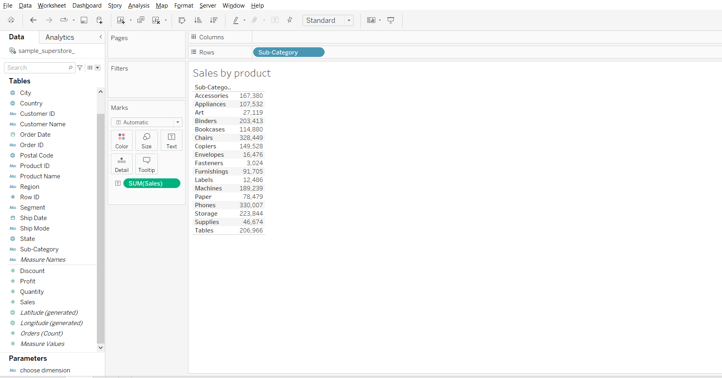

1. Creating fixed LoD calculation  
   Calculation formula- { FIXED [Category]:SUM([Sales])}

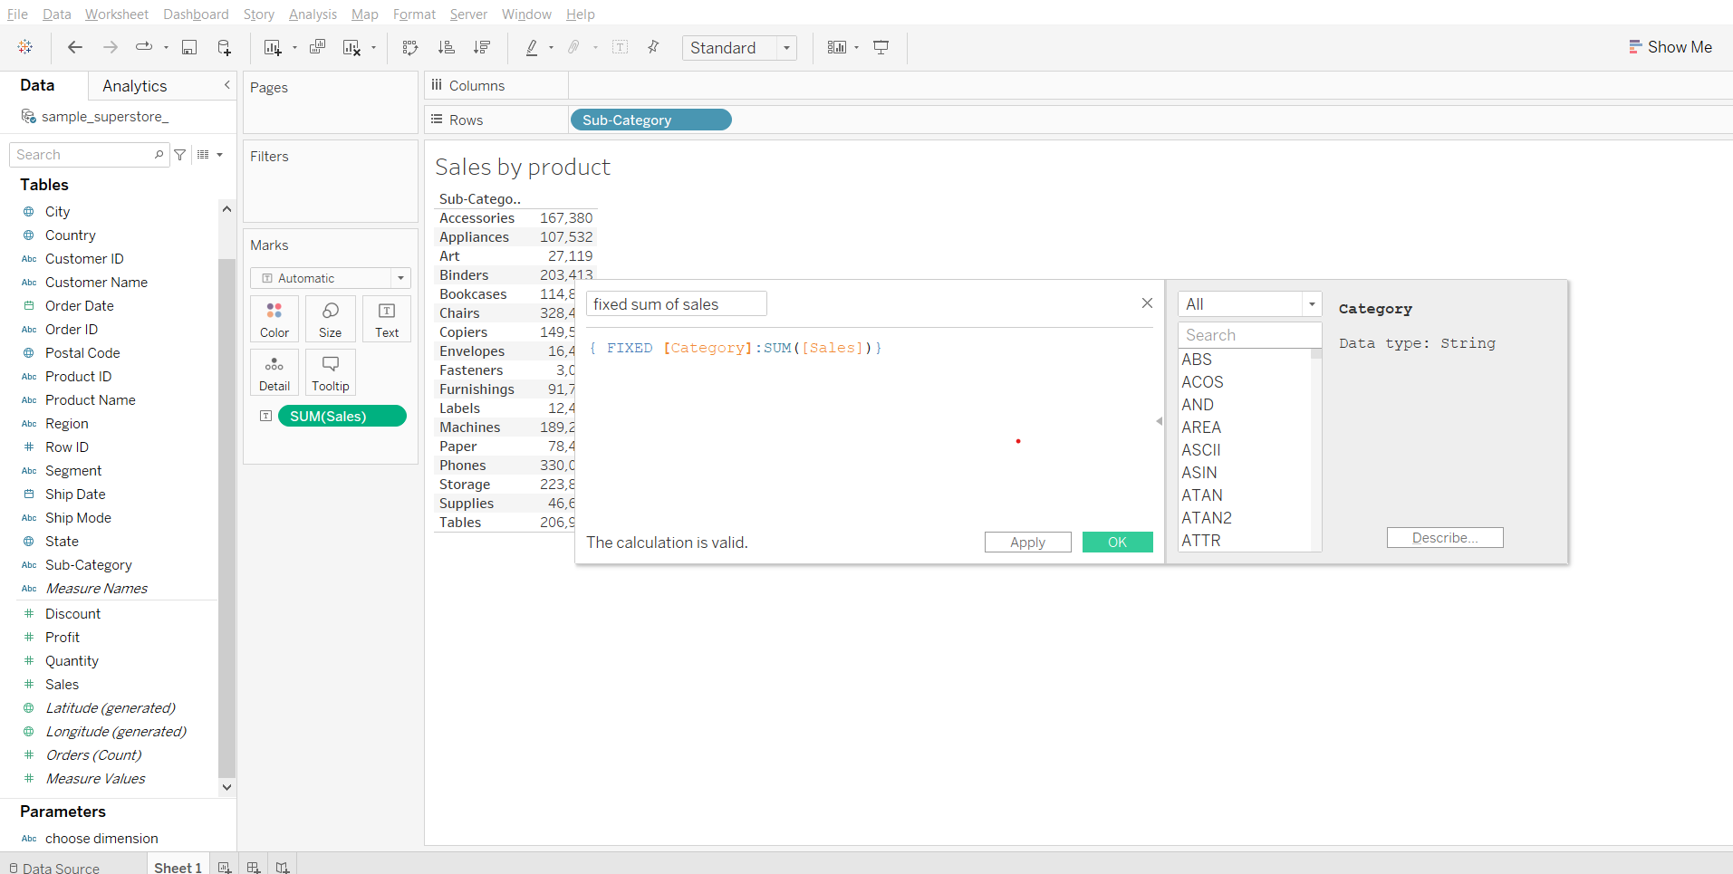

1. Solving the business problem:  
   Calculation formula- SUM([Sales])/SUM([fixed sum of sales])
   * Create a calculated field ‘Percentage of Sales’ using the above formula.
   * Drag ‘percentage of sales’ to the labels column in the sheet.
   * Change format of ‘Percentage of Sales’ to percentage, from the Measure Values card.
   * Drag Category to Rows shelf keeping it to the left of sub-category.

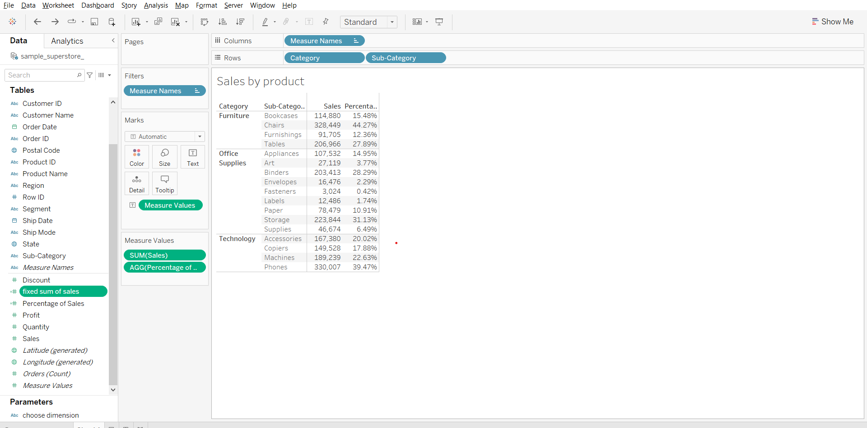\

### 

### 

### **Include Level of Detail**

It computes the value using the specified dimension in addition to whatever dimension are in the view.

You can translate INCLUDE LOD as ‘For every dimension in the view AND every listed dimension, calculate the aggregate expression’:

This is what the syntax looks like:

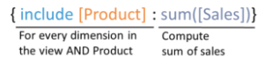

#### **Business problem 3:**

Find the difference between the total sales for each region and average sales per customer for each region.

1. Creating a include LoD calculation by customer name  
   Calculation formula- { INCLUDE [Customer Name]: SUM([Sales])}

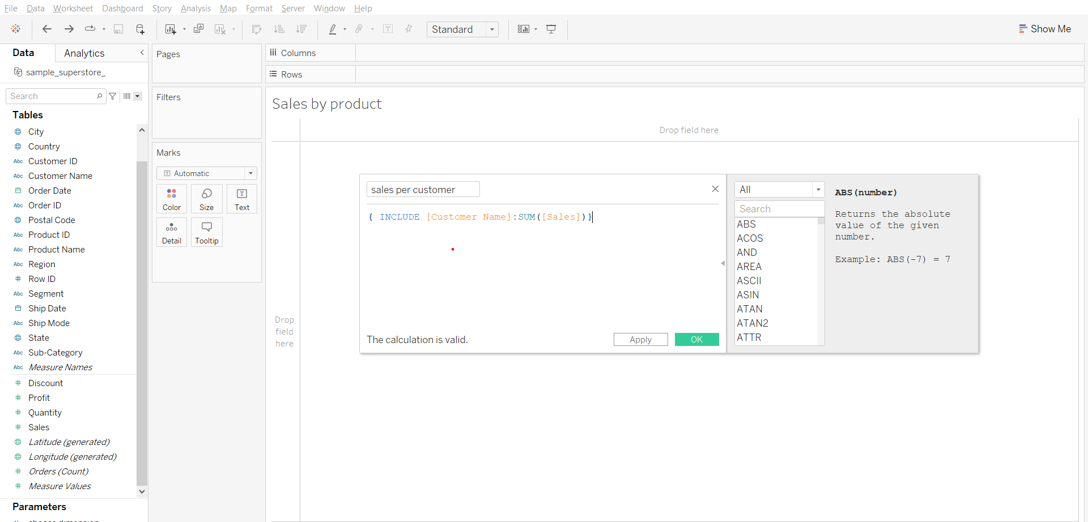

1. Plotting average sales per customer by region
   * Drag Region to Columns shelf
   * Drag sales per customer to Rows shelf
   * Change measure type of sales per customer to AVG in Rows shelf
   * Drag sales per customer to text in Marks card
   * Change measure of sales per customer to AVG in Marks card.

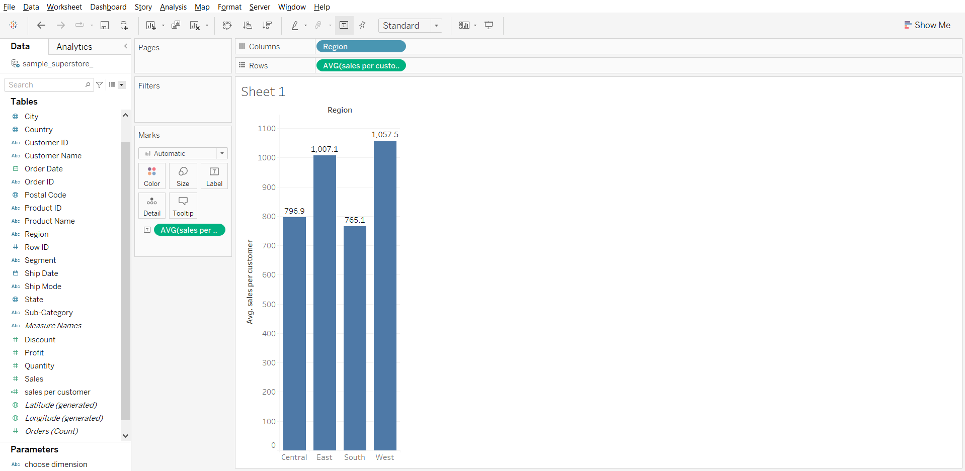

1. Solving the business problem:
   * Drag sales to Rows shelf
   * Click on sales in marks card
   * Remove AVG(sales per customer) labels
   * Drag sales to labels in sales marks card

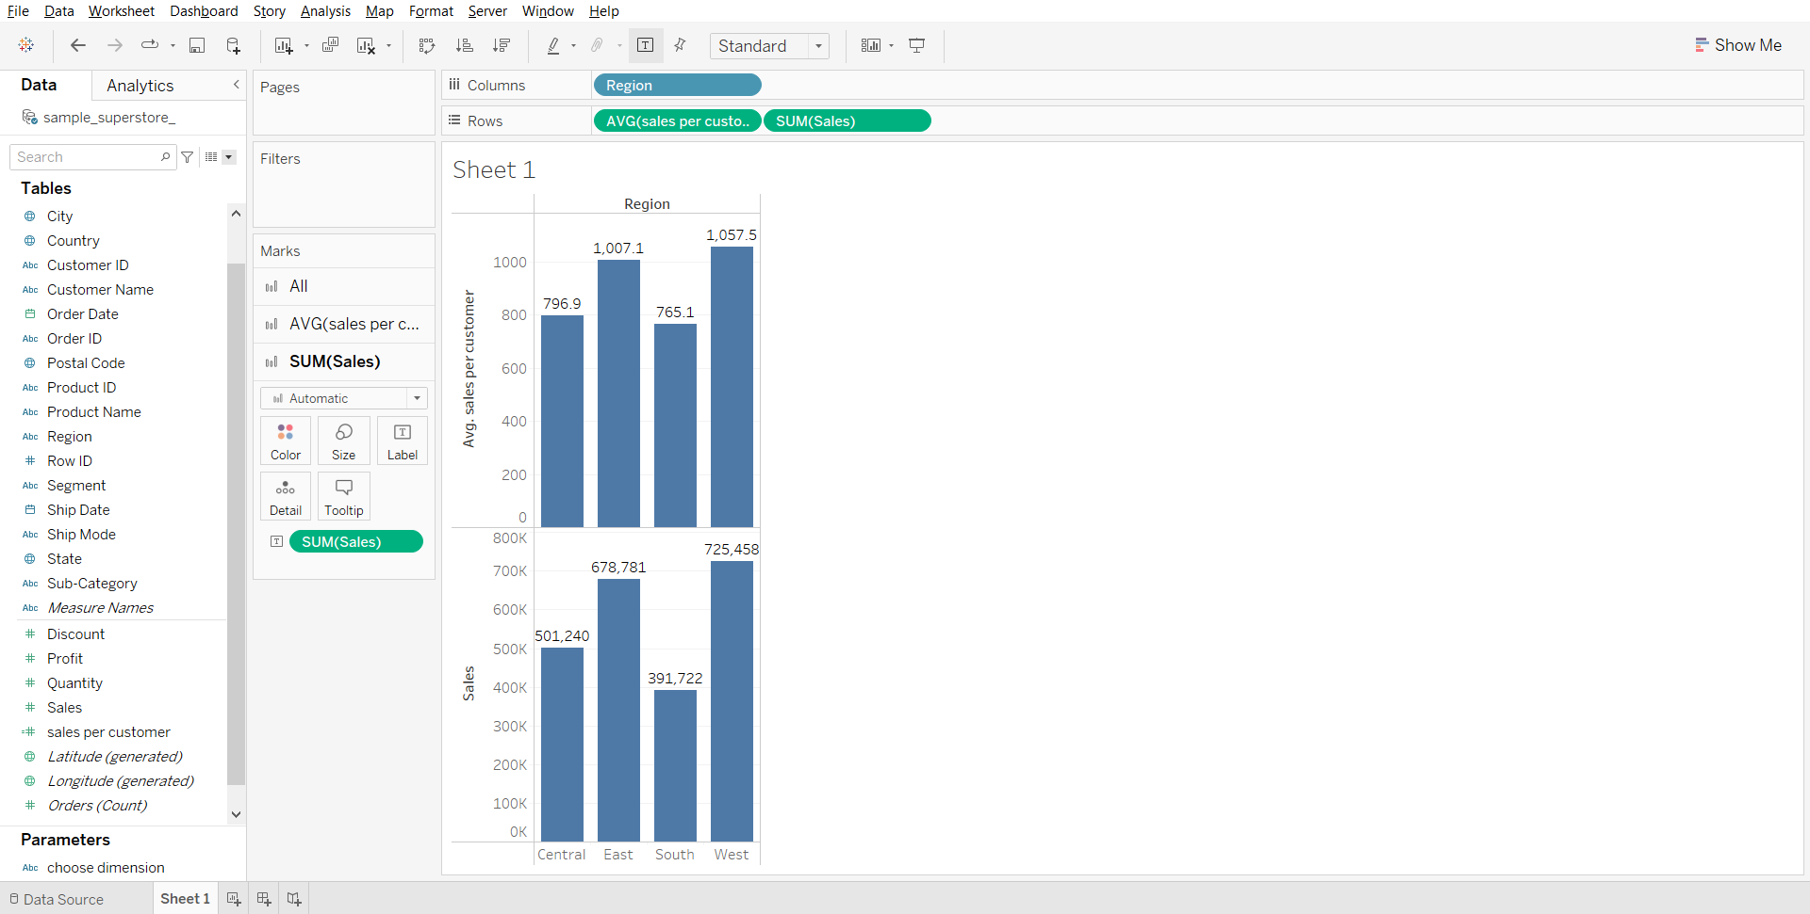

**Exclude Level of Detail**

It is pretty much the opposite of INCLUDE. Instead of adding more dimensions, you’re getting rid of them, i.e. we declare dimension to omit from the view level of detail.

You can translate EXCLUDE LoD as ‘For every dimension in the view EXCEPT the listed dimension(s), calculate the aggregate expression’:

This is what syntax looks like:  
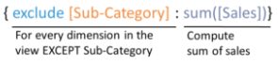

#### **Business problem 4:**

Find the difference between sales for each region by month and total sales for each month.

1. Creating exclude calculation
   * Calculation formula - { EXCLUDE [Region]:SUM([Sales])}

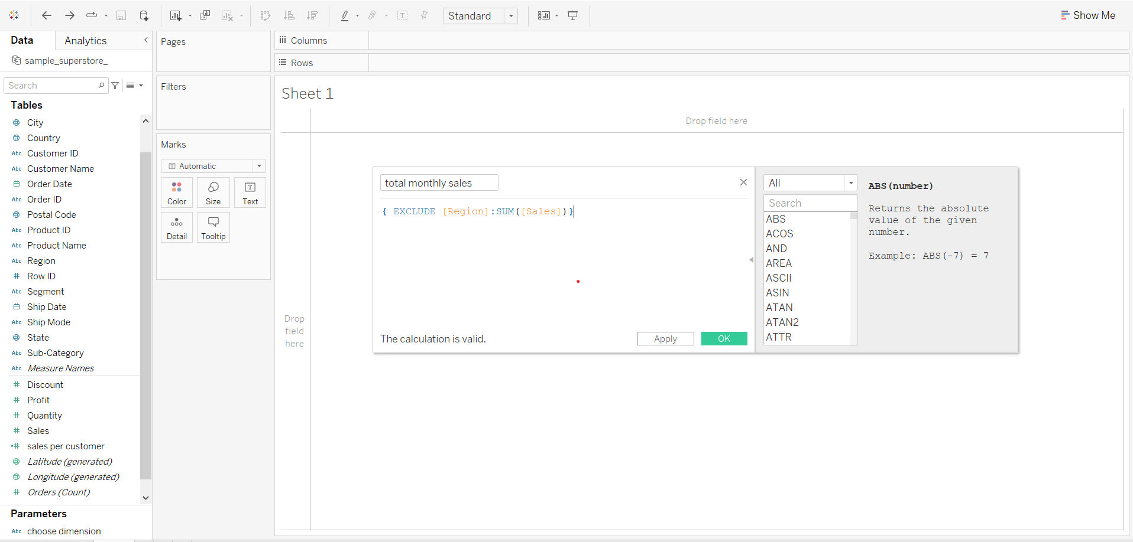

1. Plotting sales by month for each region
   * Drag order date to rows shelf
   * From the order date drop down in the rows shelf, choose Month.
   * Drag Region to Columns shelf
   * Drag sales to Columns shelf
   * Change graph type to bar
   * Drag sales to label in marks card

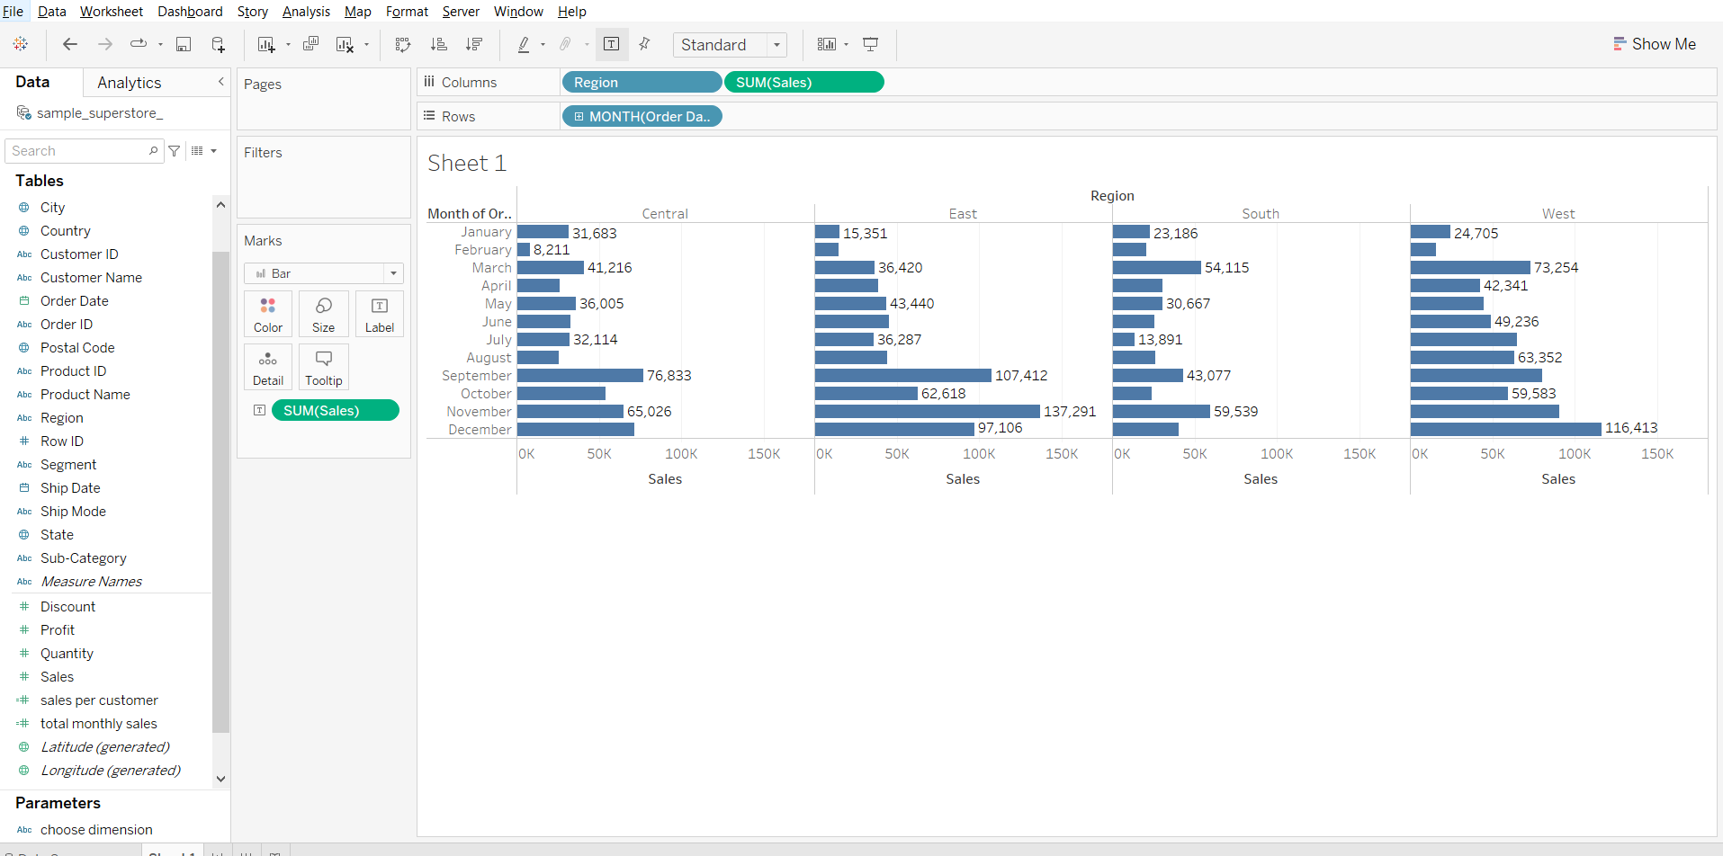

1. Using exclude calculation in color marks card to get total sales done for each month
   * Drag total monthly sales to color in Marks card

